DIS-Chinese-temple idol -Granite

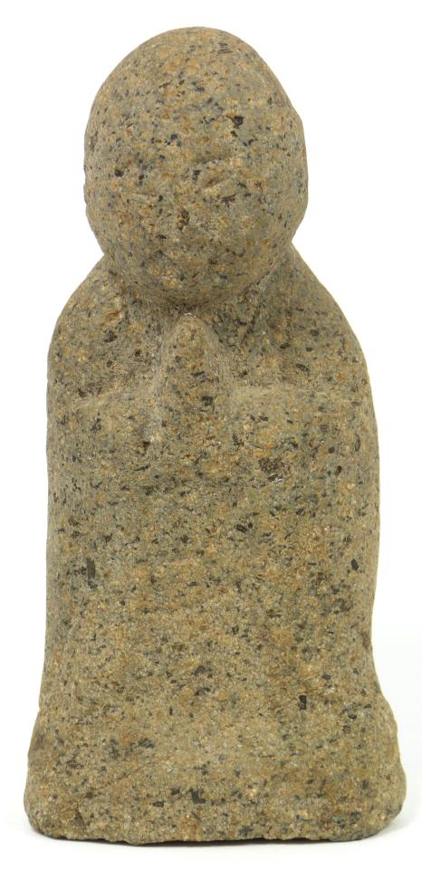

## ANCIENT CHINESE HAND CARVED GRANITE IDOL FIGURE

Ancient Chinese hand carved granite idol figure. Idol is depicted in a seated position with praying hands to front at chest. Measures 5 5/8" height (14.2cm).

Pre-Sale estimate $300-$500.